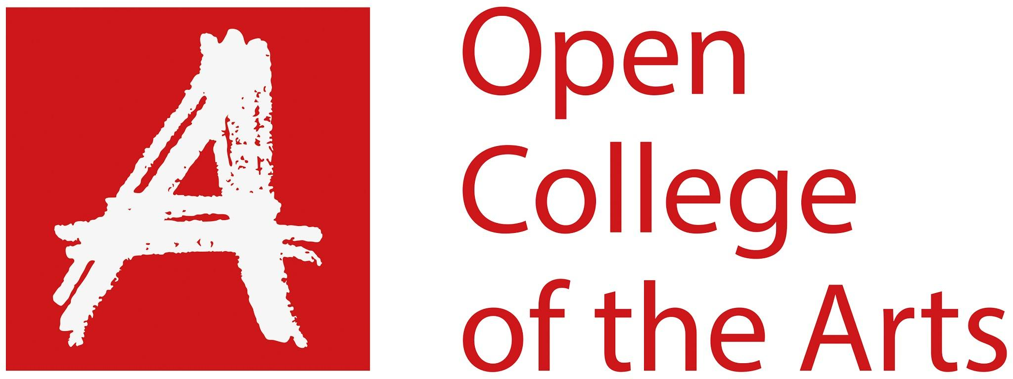

Formative feedback

Student name | Georgina Stewart | Student number | 515211
Course/Unit | Body of Work | Assignment number | 3
Type of tutorial | Phone

Overall Comments

I have been experimenting with collages for the different locations. I created several for each location, for choice mainly but also found I was enjoying creating them so didn’t stop at one. Due to the recent Coronavirus outbreak I have had to change my direction a bit.

I like the effect collages have and think it is a good choice for my topic. There is a noticeable difference between my earlier work and my newer pieces. I believe this is because at the start I was trying something new, but now I have got into the swing of things and know what I want from the images. My experimentation is going well and I still have ideas to incorporate so will keep experimenting. I believe the process I am using to create my collages is working. I have been narrowing down my images, printing them out and moving them around and seeing what works well. I want to experiment and find a different direction now as I am trying to work around the current lockdown situation, so I can continue to progress with my work.

Really good to chat with you just now, Georgina. Glad to hear you’re keeping well in these strange times.

Your work and approach have come on in leaps and bounds since we last spoke – you’ve really run with, and developed, the collage-making technique and are producing increasingly interesting and effective images. The earlier, more simplistic works in your assignment submission – while effective – are quite overshadowed by the later, more complex ones, which are terrific. In time, this will mean some careful editing decisions will have to be made, and we can talk about this next time in a video call looking at some physical prints/works. For the time being, I gather you’lll be carrying on with this developmental phase, and I definitely recommend riding this wave of enthusiasm an momentum. As mentioned, it’s such a good sign and so positive to hear that you’re enjoying this whole process so much now that you have found a technique that suits you.

You mentioned the idea of using images from your family archives as way of incorporating the female figure into the work. Great idea – I look forward to seeing what you come up with. You mention text as well – so maybe a sub-series incorporating text might be the way forward? Another idea you mentioned was mapping – again, worth trying; one step at a time. As mentioned, it will be helpful for you to maintain consistency in the colour palette(s) as you work through this – not only will it cut out some of the decision-making but will also bring important cohesion to the collective effect of the work.

In terms of research, it’s always helpful for me to see whose work you’ve been looking at and reflecting on – thank you - and the way in which you extend your research through cross referencing etc. I would recommend revisiting Hannah Höch’s work (and related critique) if (as you say) you’ve not looked at this for quite some time. I also recommend looking again at Martha Rosler’s work and her placement of the female figure within implicitly (or even explicitly) political contexts.

So pleased to hear that the ‘intuitive collage’ notes were of use. It’s also incredibly positive that you’ve been able to turn this period of self-quarantine/shielding into a period of resourcefulness and creativity rather than allowing yourself to be curtailed. Very well done indeed and I look forward to talking again at the next stage. Meanwhile, drop me a line any time if you need a second opinion on anything, and please do seek feedback on your work through at least of the online platforms.

Next Assignment
For my next assignment I will be cutting down my selection of images. These will be the main basis for my final assignment. I need to think about my editing process and refining the craft.
I will also experiment with text and how to incorporate it into my work.
I am going to see how I can incorporate female figures into my work. I will be using my own personal archive of family images for this.

Tutor name | Jayne Taylor
Date | 03/03/2020
Next assignment due | 03/05/2020 (provisionally only)

