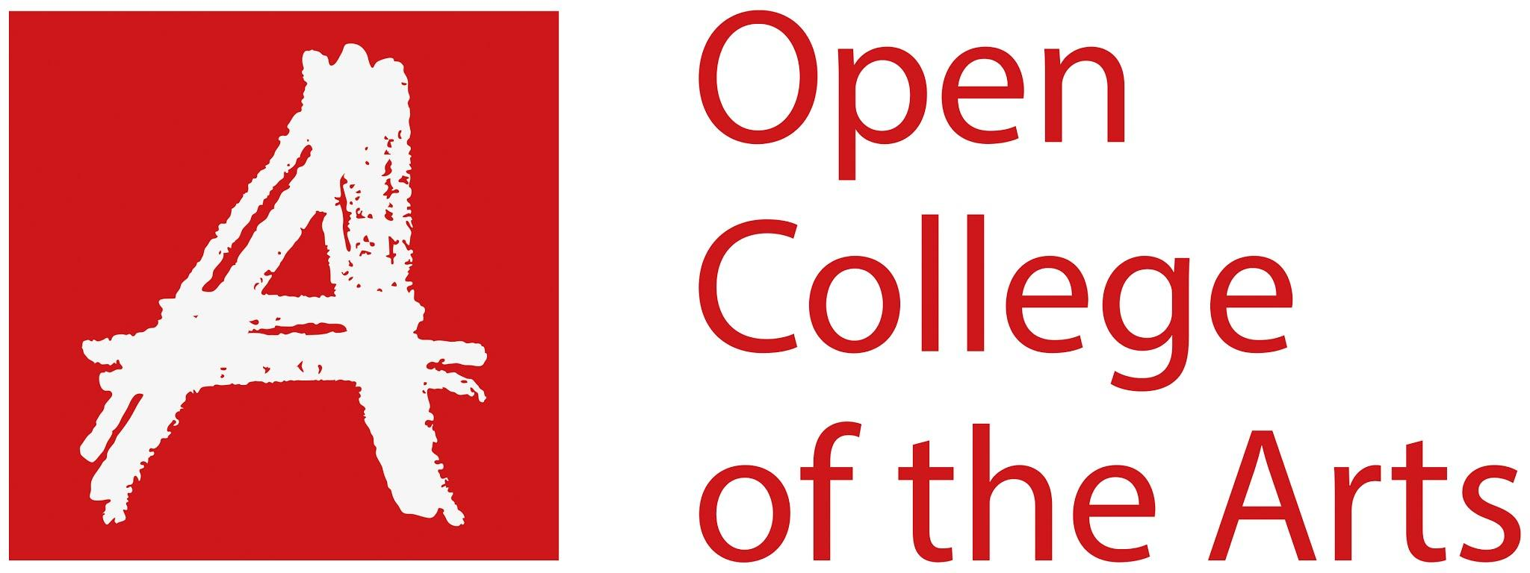

Formative feedback

Student name | Georgina Stewart | Student number | 515211
Course/Unit | Body of Work | Assignment number | 4
Type of tutorial | Written / Audio-Visual

Overall Comments

I have developed my work since my last feedback to adding an extra dimension. I have added text and a separate mapping image with images of women from my own archive. At the tutorial we discussed my images, and how they worked with the additional elements. We looked at the maps and text. In order to refining the images, I need to find out why my printer is not printing correctly, fix this, and re-print the images. I will also relook at the text, and try different font, sizes, and positioning. I will also try and create a larger map with the images that I already have as part of it, to give context to the journey. We discussed writing my introduction for the final assignment and the evaluation at the end and looked into possibilities for presentation.

Assignment

For this assignment, I have eight images. I narrowed these down from my previous assignment. I have made notes on my learning log of how I did this. I decided to add another element to my work by including a mapping image. I felt this had it’s place as it is a journey, so may give context to the location. I also wanted to incorporate my version of a ‘strong’ woman, which I have done in the form of my own family archives. I feel this is much more personal to me, as they are my family, they are on the journey with me (on the maps), but do not feature on the main image (sort of excluded from the main part). I have tried different ways of positioning the images in relation to the main image. I have also included text, in the form of quotes from the bible, which highlights the inequality found in religion and in society. There are three main elements to my work, almost like a triptych theme, in keeping with the religious theme.

Learning Log

I have completed the exercises for this section. I am keeping up to date with uploading and updating my learning log.

Suggested reading/viewing

Sophie Calle – How the artist has displayed the text in their work.
‘Continuous Signal’ – Zoe Leonard.
Cyanotype

Pointers for the next assignment / assessment

- Experiment with the text – Size, Position, & Font
- Refine the Prints – re-printing, fixing printing issue, carefully cut-out fot the collage
- Experiment with creating a larger map to show the journey
- Title
- Introduction
- Evaluation – explain the concious decisions

Some very positive steps forward here, Georgina, in terms of:-
- Editing of the location images
- Introduction of “strong women” from your personal photo archive
- Interpolation of the location images and maps, representing the pilgrimage/landscape itself.

The themes of exclusion, inequality and subjugation are strong in your research, development and in the images themselves. The order of the images/text might be strengthened through adopting a narrative and/or chronological approach.

The collages – while terrific in this new configuration - need a little refinement in terms of reproduction and perhaps modification of the colour palette to increase the overall visual coherency of the piece.

As discussed, it’s important not to overlook the signifying power of the typeface itself. Whatever is connoted through your choice of font will become part of the overall ‘message’ (albeit semi-subliminally)≤ so choose your typeface carefully and with attention to both its visual qualities and its contextual associations.

We discussed works by Sophie Calle and Anna Fox in relation to your work. I will send you the essay I mentioned, by Zoe Leonard, in a separate email. The essay is made up of separate extracts of quotes/original text to form a new piece in itself – in a style quite closely to your cut-and-paste collage work, in a way.

In terms of presentation and layout, there is still plenty of experimentation needed around different papers and placement/appearance of text, etc.

Overall, things are beginning to come together very strongly now and this is a testament to your willingness to take risks, the quality of your research and the strength of your conviction. Well done.

Jayne Taylor

Strengths | Areas for development
Experimenting | Printing
Images | Cutting out for the Collages
Choice of text and additional elements

Tutor name | Jayne Taylor
Date | 17/6/2020
Next assignment due | 1st of August 2020?

