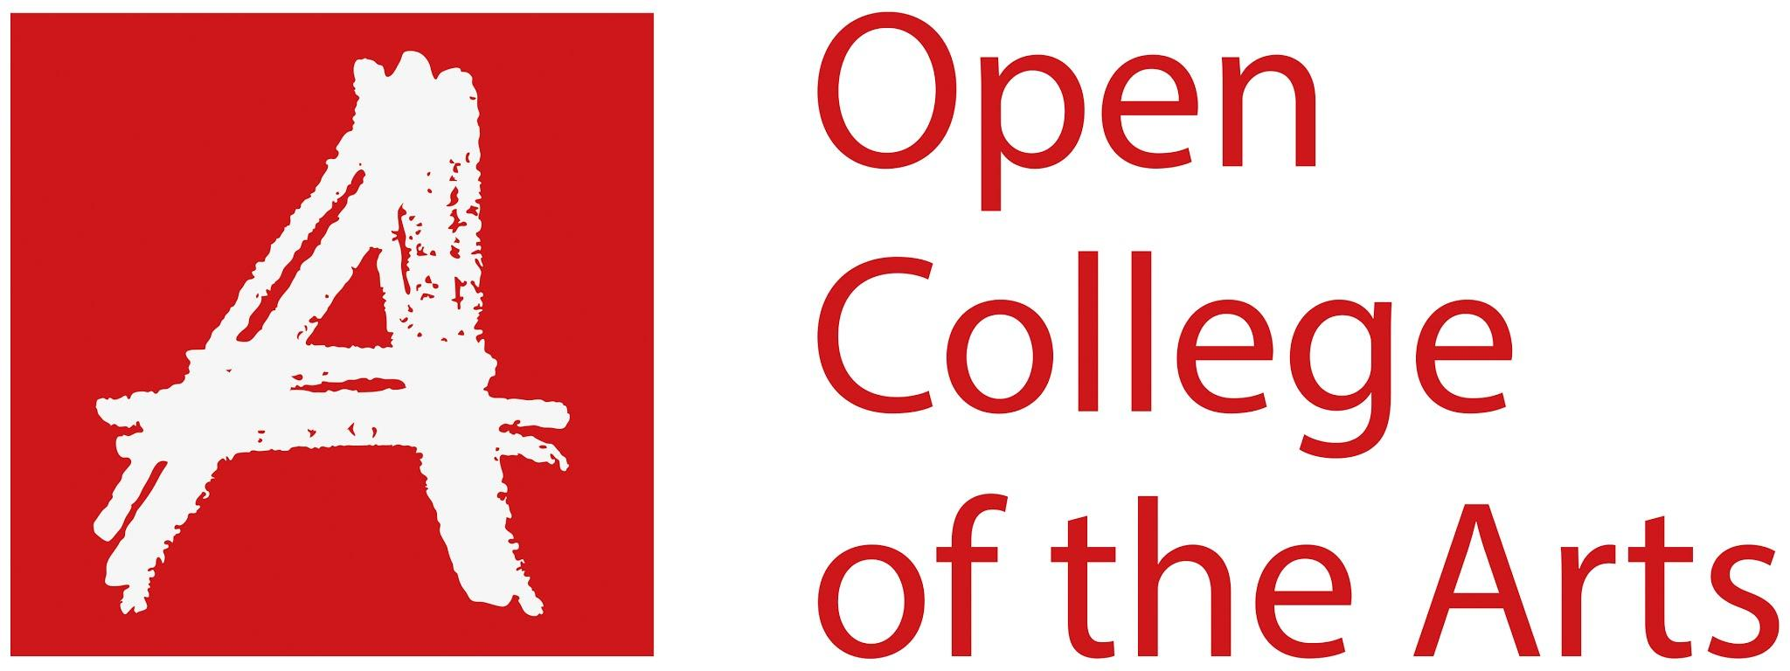

Formative feedback

Student name | Georgina Stewart | Student number | 515211
Course/Unit | Body of Work | Assignment number | 5
Type of tutorial | Written / Audio-Visual

Overall Comments

This is my final tutorial for this course. I have developed my work since my last tutorial and have addressed a few issues. I fixed my printer and brought some Matt Photo paper. I reprinted the images and remade the collages for a better finish. We looked at my images and read through my introduction. I am happy with how my work has developed and I just need to modify a few things. I have thought about presentation methods and have decided a newsletter format will be appropriate.

Assignment

My assignment comprises of eight images, with two images and text. I have redone the images for a better finish, which I am happy with. I have changed the text to a clearer font, which is as close as I could find to the font in the Bible. I have made the text bigger in comparison with the images. I need to change the colour of the text from black to grey. We looked at my introduction, a few words need changing and a slight reformat is needed. I need to incorporate some background into my introduction in relation to my title. I should also start my introduction by going straight into the pilgrimage. We discussed the presentation, which will probably be in a newsletter format.

Learning Log

I have kept my learning log updated.

Suggested reading/viewing

Assessment Criteria
Course Learning Outcomes
Sophie Calle

Pointers for the next assignment / assessment

- Change the text from Black to grey
- Change a few words in my introduction
- Re-format the introudction
- Create some newsletters & a video to show it

Hi Georgina,

Thank you for sharing your summary so promptly. It was fascinating to see the progress in your work since we last spoke – you have taken the points from our last conversation and applied them to this final developmental stage in the work.

The collage works now have much more aesthetic coherency, due in part to the improved reproduction and improved consistency in the colour palette. Your archival images combined with the map sections are effective, expressive and bring another dimension to the work. You have chosen a suitable typeface, which is appropriate for the subject matter in that it signifies a conventional ‘bible’ text. (As discussed, I would suggest rendering the text in something like an 80% grey, as this tends to look a touch more professional than black.) The narrative flow – which you organized text-first – is also now working really well, and you’ve shown good judgement in selecting and organizing these texts.

As discussed, considerations between now and assessment:-
- Acknowledge and reflect on the bluish colour pallete: there are certain connotations here of a time passed/bygone era (as images tend to lose red pigment first and become more blue in overall tone) – think of faded postcards for example, or old notices in shop windows. How might this tie in with the message of your work? It needn’t become completely intrinsic but, at the same time, it is important to acknowledge the conscious decision you have made here and the implied, almost-sublimal, meaning.
- Font colour (as above).
- Title and introduction: It can be hard to title a work, so take your time and be aware that an impactful, title can be the best introduction to a piece if carefully chosen. The draft of your introductory text, whilst well-written, needs to get straight to the point (I feel), which is the historical exclusion of women from religious pilgrimages (against a backdrop of inequality more generally) and your personal interest/background in religious studies. Currently the text orientates the first-time viewer in notions around the landscape genre, which – though fine as context - seems off the mark in terms of the (much more interesting topic) of what work is really about. See if you can approach the text in the same way as your image editing. Knowing what to take out is at least as important as knowing what to include. I’m happy to look over a second draft whenever you’re ready.
  - The word ‘excluded’ seems key in respect of position the viewer in relation to the images. The text needs one or two cues to hook the viewer in, while at the same time avoiding being overly-prescriptive. Your idea for the ‘[…] Shadows’ title would work very well but try not to settle on a title without exploring a few more options first.
- Think about your chosen output for the work in terms of presentation – you mentioned experimenting with different papers and print sizes, which is exactly the thing to do. Your idea for an A5 pamphlet-style publication would suit the church theme very well and could be an ideal way to disseminate the work to a chosen audience (women’s groups? Christian groups? General public?). I would also recommend producing a set of fine art, exhibition-ready prints (despite the current digital assessment process) – perhaps presented in a portfolio box? (See Diane Arbus’ ‘A Box of 10 Photographs’ as an example. Dayanita Singh has also produced some innovative “boxed exhibitions (with another currently in progress for Photoworks), which might provide inspiration for further iterations of the work for SYP.
- Finally, be sure to tie your visual and theoretical research together in your final written reflection. One approach to this is to include hyperlinks to previous learning log entries as a way of highlighting what has informed your concept and your creative approach.

As mentioned, I’m more than happy to take a brief look at the work again before your assessment submission. Be aware that the new assessment process relates directly to your own reflection on how your practice has developed in alignment with the course Learning Outcomes.

You have shown an impressive arc of development over the course, Georgina, and you have engaged with and integrated some important creative practices into your way of working – for example, using workprints at the editing/selection stage; photocollage technique; consideration of the visual implications and placement of text; working with ‘found’ archival images. It’s been a pleasure working with you and I wish you all the best with your assessment preparation.

Strengths | Areas for development
Development | Link how I have used my research and how I have implemented it in my work
Creating a Simple yet Complex piece of work | Change the format of my introduction
Research

Tutor name | Jayne Taylor
Date | 4/8/2020
Next assignment due | Please remember to include a date here, even if it is nominal

